1.13.4-ALG notificationAndNewsFeedbackAnalytics() Algorithm
Purpose:
This algorithm processes user interaction events related to notifications and news content for analytics purposes. It validates incoming event data, records the interaction in the analytics repository, determines whether processing was successful, and returns the status of the operation along with any validation or processing errors.
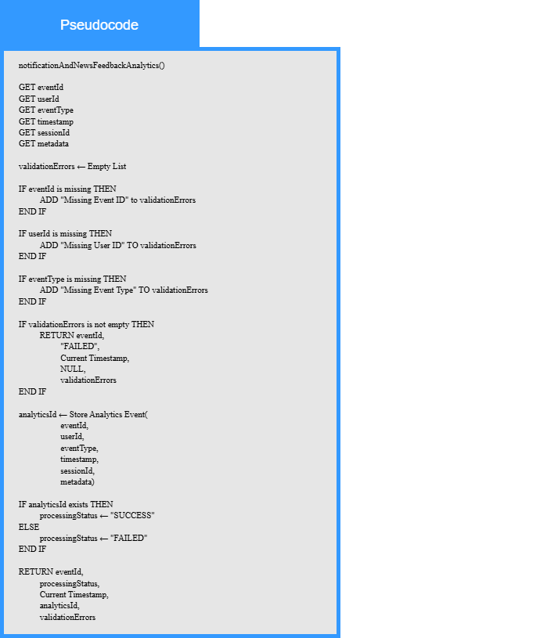
Local Data:
analyticsId : Analytics Identifier
processingStatus : Status
validationErrors : List of Error Messages

